Getting into your files at Bankhead from home

You want to work on your school file at home…BUT…your file is at school!...SO…

- Open the school website on your computer at home
- Click on Utility Links [top left]…at the right end of the drop-down menu, click on "Sign In". Use the username and password you always use at school. Signed in? Good…
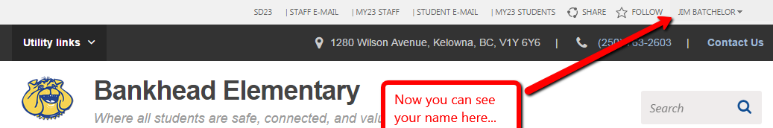
- Now your name can be seen at the top right of the screen:

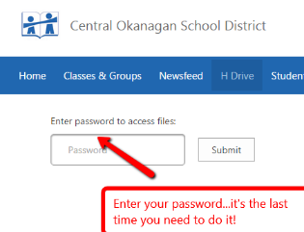
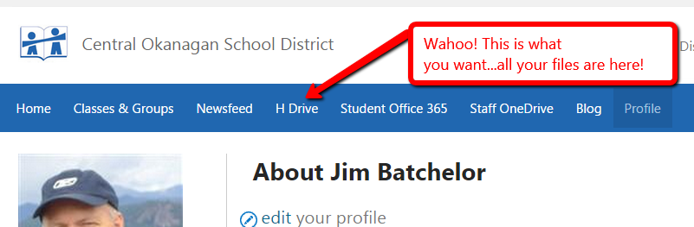
- Click on your name, then click on "About Me". You may need to log in again at this point. In the long, blue strip you will see "H Drive". Click on it. You will need to type in your password again.

- You are now looking at all your folders and files at Bankhead.
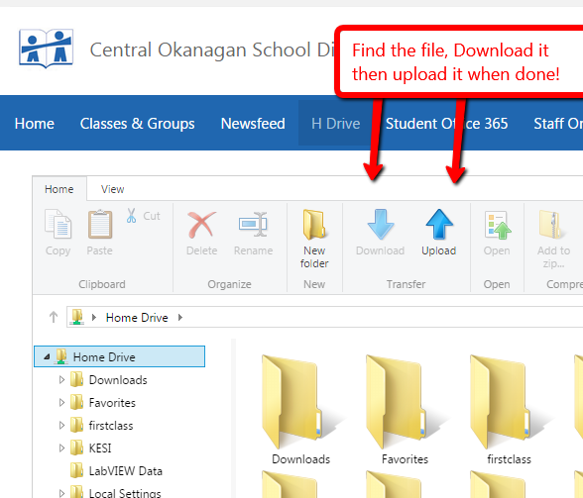
  - Find the file you want to work on.
  - Use the 2 arrows you see below for upload and download. Use the download arrow to save the file to your desktop. Minimize the Bankhead window so that you can upload the file you work on back to Bankhead.
  - Complete the work you want to do. When you click "Save" on your computer, it will save changes to your desktop. Finished?
  - Now click the "Upload" arrow to move the file you worked on from your desktop back to the Bankhead computer. Find you name at the top, right of the Bankhead window, click on it and "Sign Out"! You're done! Yay!

